|  |  |
| --- | --- |
| **Ex.No : 10** | **Implementation of KVM in ubuntu Virtual Machine** |
| **17.05.2022** |

# Aim :

To implement the KVM in ubuntu and create a virtual machine in KVM .

# Procedure :

**Step 1 :** Give lsb_release – a tp check the ubuntu version details

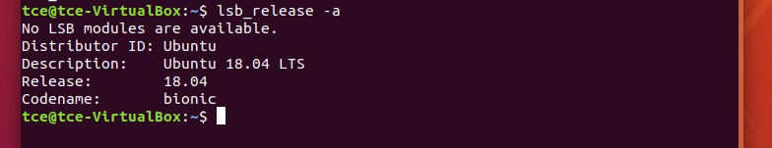

**Step 2 :** Type ip a| more to show the ip address or use ipconfig to know ipaddress of that machine.

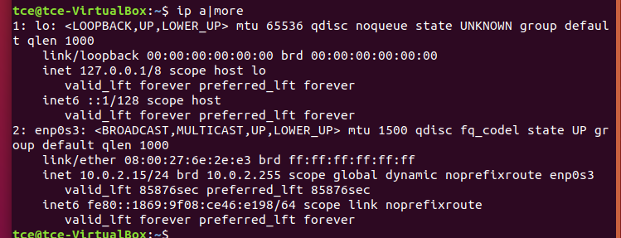

**Step 3 :** Type uname –a to know about the architecture of that machine (need to be x86)

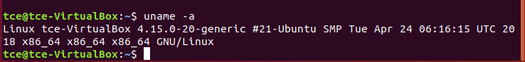

**Step 4 :** Make the normal user to sudo user by typing sudo su and give apt-get update to update all packages to up-to-date.

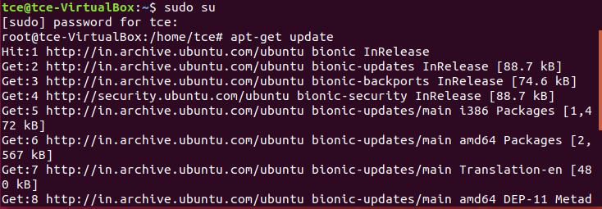

**Step 5 :** In order to install the required package u need to kill the existing running port number . Use ps –ef | grep apt to know the port details , use kill -9 [portnumber] to stop the process.

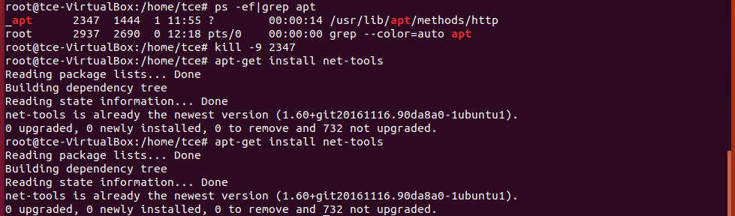

**Step 6 :** Use apt-cache search qemu-kvm to search the virtualixation is available or not.



**Step 7 :** If available download the necessary package , use apt-get install [package-name] qemu-kvm , libvirt-bin , bridge-utils , virt-manager , qemu-system

Else u can give directly by

apt-get install qemu-kvm libvirt-bin bridge-utils virt-manager qemu-system

# The above one will install all the necessary package , If u got error in installing libvirt-bin then repeat the step 5 to kill the running process.

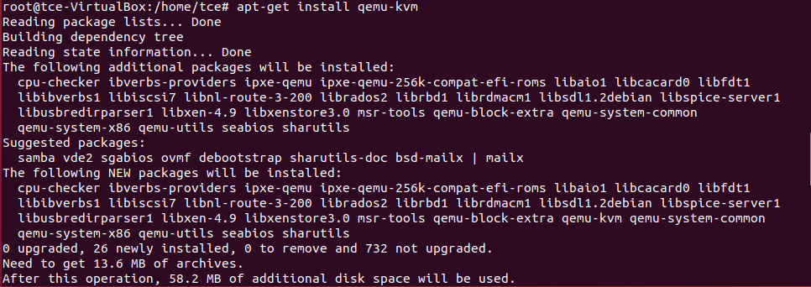

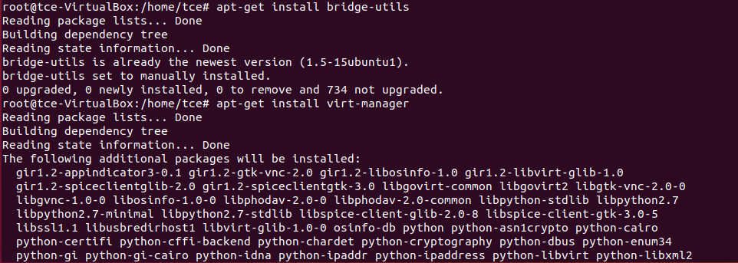

**Step 8 :** Configure the libvirt.conf file by typing sudo nano /etc/libvirt/libvirtd.conf

# listen_addr = "0.0.0.0" unix_sock_group = "libvirt" unix_sock_ro_perms = "0777"

**unix_sock_rw_perms = "0777" unix_sock_dir = "/var/run/libvirt" auth_unix_ro = "none" auth_unix_rw = "none"**



**Step 9 :** restart the libvirtd .

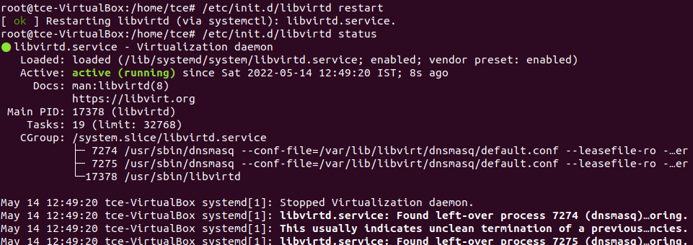

**Step 10 :** type virsh to open the virtualization terminal.

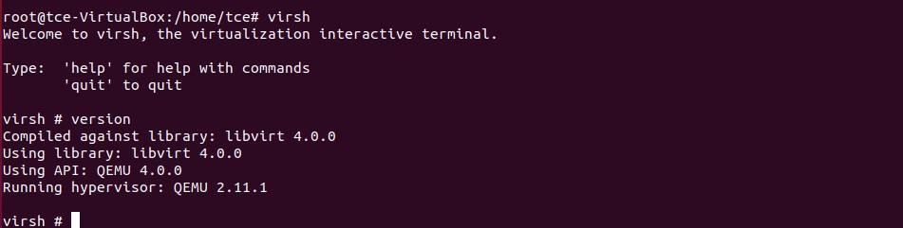

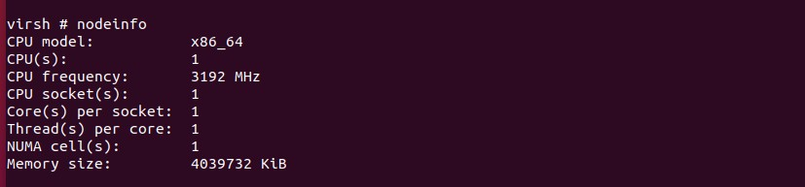

**Step 11 :** Click new VM , Launch existing disk image , import existing disk image , provide the path of u downlaoded image file give OS type as generic , give name for VM. Click finish.

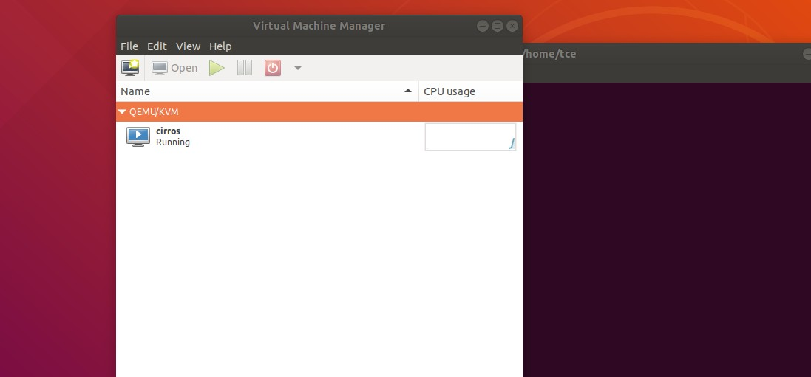

# Step 12 : Run the virtual machine .

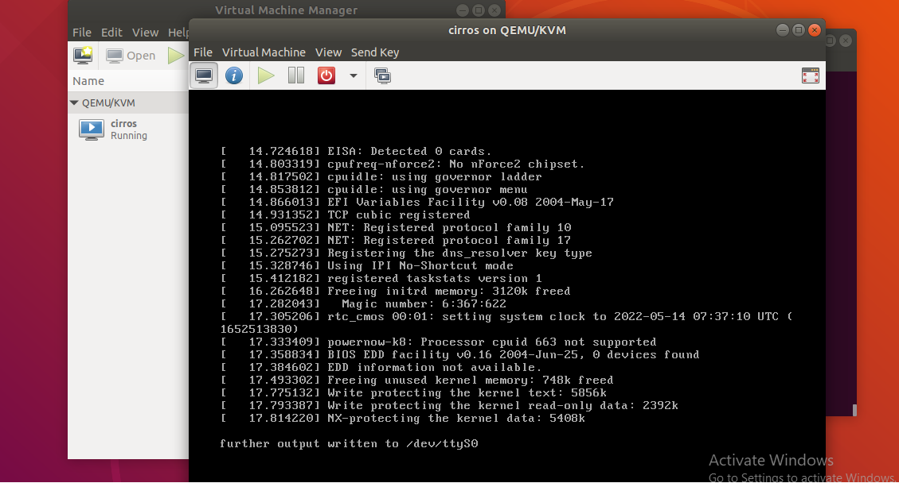

**Result :**

Thus , the KVM installation and creation of VM under KVM is implemented successfully.